**MXET 375**

**Applied Dynamic Systems**



**LABORATORY # 3**

**Spring Mass Damper System**

**Submission Date: 09/26/2024**

Name: Kyle Rex

Section: 906

UIN: 932008894

# Introduction

The purpose of Lab 2 is to expand an individual’s knowledge on how to model a physical two-degree-of-freedom spring-mass-damper system using Simscape libraries in Simulink and MATLAB. Additionally, it aims to demonstrate how to utilize Simulink’s parameter estimation tools, based on experimentally collected data, to better align a simulation model with the behavior of a real-world system. The objectives include gaining a general spring and damping functionality understanding, learning to create block diagram models using different Simulink libraries, and appropriately configuring simulation values to match the experimental values through the use of parameter estimation tools. Task 1 focuses on providing a physical model demonstration resulting in experimental data that is used to analyze the system by creating a position plot using excel. Task 2 focuses on creating a model spring mass damper system using Simscape that is used to analyze the system by creating a position plot. Task 3 focuses on aligning the simulation results more closely to the physical test results through the use of Simulink’s parameter estimation tool that uses the experimental data to better estimate what the system variables should be for the Simulink simulation to better match the physical test. At the end of the lab not only should the individual have a better understanding of using the Simulink estimation tool for better aligning simulation variables to physical variables but also creating, plotting, configuring, and formatting mass damper system models, and their results, using Simulink, Simscape, and MATLAB.

# Procedure & Lab Results

This lab has 3 tasks total. Each of these tasks only has 1 part. Each task includes a detailed description of the setup, procedure, results, relevant figures, and discussion focusing on developing a better understanding and interpretation of what the results mean and how they were derived. For this lab specifically it is important to understand and recognize that the models are representative of an actual model. and are not just simple plots. This means that the y-axis and what the lines represent are defined.

## Task 1

Task 1 focuses on providing a physical model demonstration resulting in experimental data that is used to analyze the system by creating a position plot using excel. The purpose of this task is to expand the understanding and precision in modeling spring mass damper systems. The suspended 2 degree of freedom spring mass damper system being used to collect this experimental data can be seen in Figure 1.

Figure 1: Physical Spring Mass Damper System. [1]

It has only one input force, which is gravity. The procedure and demonstration for performing the test is shown and explained in a provided video. Following this procedure the “SMDS_Data.xlsx” file was created and provided. This file provides the position data of the two mass system from 0 to 4.5 seconds. With this data the plot that can be seen in Figure 2 can be created by highlighting the relevant data, making a scatter with smooth lines plot, and formatting in with proper labeling.

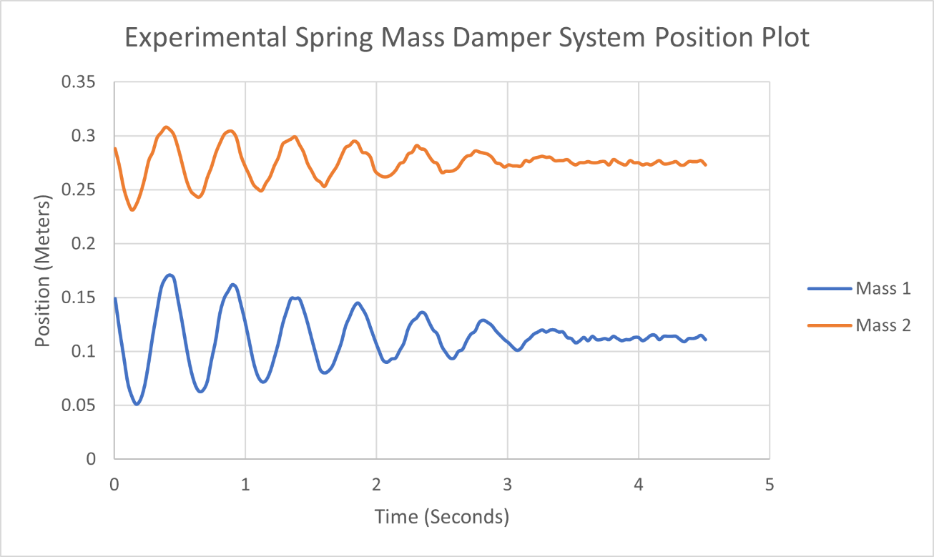

Figure 2: Task 1 Experimental Spring Mass Damper System Position Plot.

This plot represents the behavior of the system based on its experimental data and therefore represents the correct appearance of the position plot for this system. This allows for the comparison of accuracy between this plot and the Simulink simulation plot result. Based on the resulting plot it can be inferred that the system is clearly an underdamped harmonic oscillator where the spring forces and damping resistances cause oscillations that eventually stabilize as the system returns to equilibrium. The oscillations have a higher amplitude at the beginning and then over time they decay. The different oscillation behaviors between mass 1 and mass 2, such as mass 2 having smaller oscillations than mass 1, indicates that they are either subjected to different damping, spring constants, or have different masses, causing the variance in the amplitude and frequency of their oscillations.

## Task 2

With the completion of Task 1, which resulted in an experimental data position plot for the spring mass damper system, the focus of Task 2 shifts to modeling the physical system in a Simulink simulation using Simscape. The purpose of this task is the same as task 1, which is to expand the understanding and precision in modeling spring mass damper systems.

This task provided the assignment of creating a block diagram of a spring mass damper system using common control system elements and the Simscape Library. This system is made up of a step block, three mechanical translational reference blocks, a simulink-PS converter block, two mass blocks, an ideal force source block, two PS-simulink converter blocks, two ideal translational motion sensor blocks, a solver configuration block, two translational spring blocks, two translational damper blocks, a bus creator, and a scope block. The provided lab manual for this lab walks through the exact setup, configuration, and procedure for creating this block diagram.

The procedure for this began with importing all the required blocks and setting them up in the correct setup configuration. The setup configuration of the required block diagram to produce the correct plots, with all block names, can be seen in Figure 3.

Figure 3: Task 2 Spring Mass Damper System Using Simscape Complete Block Diagram

Once this is complete some variables must be configured with their respective values so they can be integrated into this system. This can be done in the Simulink interface itself or with the MATLAB command window. In this case it was done using the MATLAB command window as seen in Figure 4 where y (step value) is set to 2, k1 (spring rate 1) is set to 150, k2 (spring rate 2) is set to 75, b1 (damper coefficient 1) is set to 5, and b2 (damper coefficient 2) is set to 0.5. After the values are set the Simulink diagram must be updated by right clicking in the diagram and clicking “update diagram”.

Figure 4: Task 2 MATLAB Variable Assignments Before Estimation.

With the setup complete, and variables assigned, the next step was to configure each block with the appropriate values. In the case of this problem that is done by setting the final step value to y, step time to 0.2 seconds, spring 1 rate to k1 N/m, spring 2 rate to k2 N/m, damper 1 coefficient to b1 N/(m/s), damper 2 coefficient to b2 N/(m/s), mass 1 to 0.207kg, mass 2 to 0.308 kg, mass 1 initial position to 100mm (under “Ideal Translational Sensor 1”), mass 2 initial position to 270mm (under “Ideal Translational Sensor 2”), spring 1 deformation to 10 mm (under “Initial Targets”), and spring 2 deformation to 20 mm (under “Initial Targets”). Some of these values are based on variables but others are constants that were measured to directly relate specifically to the physical model itself to create a more accurate simulation. Lastly, in the configuration parameters window of Simulink the stop time must be set to 4.5 seconds to match the experimental data, the max step size must be set to 0.2 seconds, and the solver must be changed to “ode23t (mod.stiff/Trapesoidal)”. Once that is complete the final step is to run the system and format the result to the specified requirements described in Lab 1. This result can be seen in Figure 5.

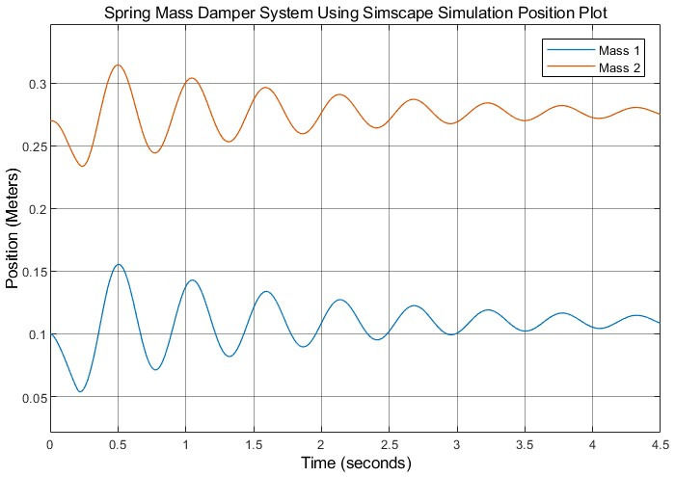

Figure 5: Task 2 Spring Mass Damper System Using Simscape Simulation Plot Before Estimation.

Based on the resulting plot it can be inferred that the system has all the same characteristics explained at the end of Task 1 which is expected since it is meant to be a representative model simulation of that physical system. The general behavior of the system in both the physical data plot and simulation plot are similar, but the physical system shows some irregularities and more rapid damping due to real-world imperfections, while the simulation presents a more idealized, smoother oscillatory response. Adjusting the parameters of the Simulink model (such as the damping coefficient or spring constant) could help the simulation better match the real-world data.

## Task 3

With the completion of Task 1 and 2, which resulted in an experimental data position plot and a Simulink simulation position plot for the spring mass damper system, the focus of Task 3 shifts to getting the output of the simulated plot to match as close as feasibly possible to the experimental plot. This is done by configuring the variable values of the simulation using a parameter estimation tool, therefore configuring the simulation results, to better relate to the physical results. The purpose of this task is the same as the previous tasks, which is to expand the understanding and precision in modeling spring mass damper systems.

This task provided the assignment of using the previously created simulation of a spring mass damper system from Task 2 and the parameter estimation tool to create a more accurate simulation. While the simulation remains mostly the same, one change is made which is assigning values of Mass 1 and Mass 2 to respective connections going into the scope. The simulation with this new addition can be seen in Figure 6.

Figure 6: Task 3 Spring Mass Damper System Using Simscape Complete Block Diagram

Once this is complete the physical system data will be imported into Simulink and then ran through the parameter estimator which calibrates and determines values for the variable parameters of the system that will result in a more accurate simulation that better represents the physical model. The procedure for this began by creating a new experiment in the parameter estimator and assigning the output signals that were identified previously as “Mass 1” and “Mass 2”. Once these signals are added to the output table the next step is to import the experimental data from the physical system. This is done by navigating to the excel file and then separating and selecting the excel data for each mass in the import selection window and importing them each as separate data groups. Once this is done for each mass the parameters being configured must be identified in the “Select Model Variables” menu. Select all of the variables listed as continuous variables which include b1, b2, k1, k2, and y. With the variables selected the next step is to plot and simulate the experiment which will result in a plot of the experimental and measured data for each mass which can be seen in Figure 7.

Figure 7: Task 3 Parameter Estimator Plots Before Estimation.

With this experiment complete the next step is to run the actual parameter estimator as these current plots show the results with the parameters that were set in Task 2 before any estimation tool configured them. While the results do seem similar, they are not exactly the same, which is the goal when creating simulated systems meant to match physical systems. The process to run the parameter estimator begins by clicking on the “Estimate” button on the parameter estimation tab and letting it run for a few minutes. After it is completed, it will result in a parameter estimation graph that can be seen in Figure 8 which shows the progression of the variables being configured to better match the measured output to the simulated output for each mass.

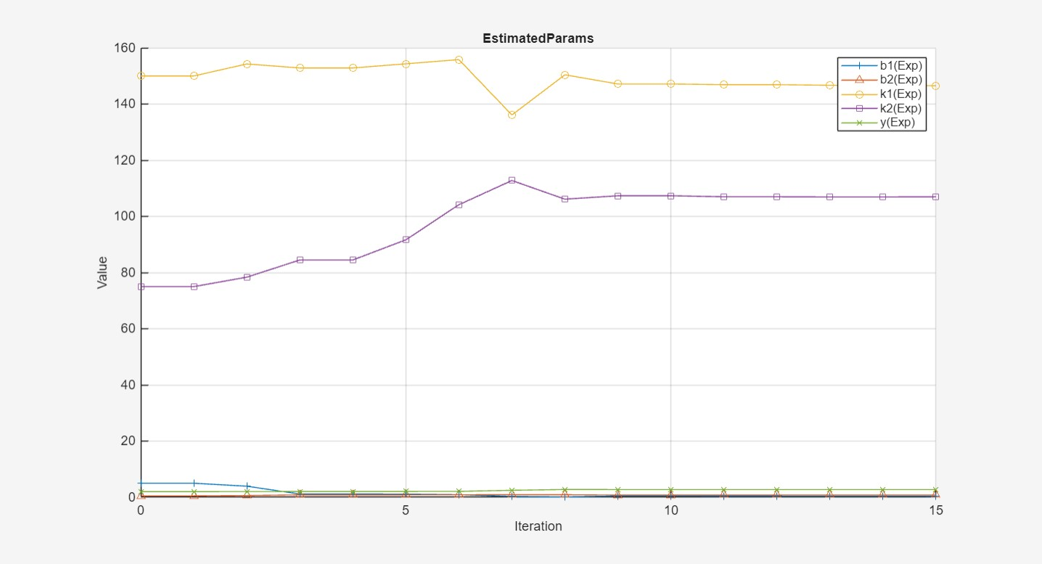

Figure 8: Task 3 Parameter Estimator Plot During Estimation.

The estimation will also result in the corrected plot of the experimental and measured data for each mass with the new variable assignments which can be seen in Figure 7. This is a much more acceptable similarity between the results of the experiment and the results of the simulation.

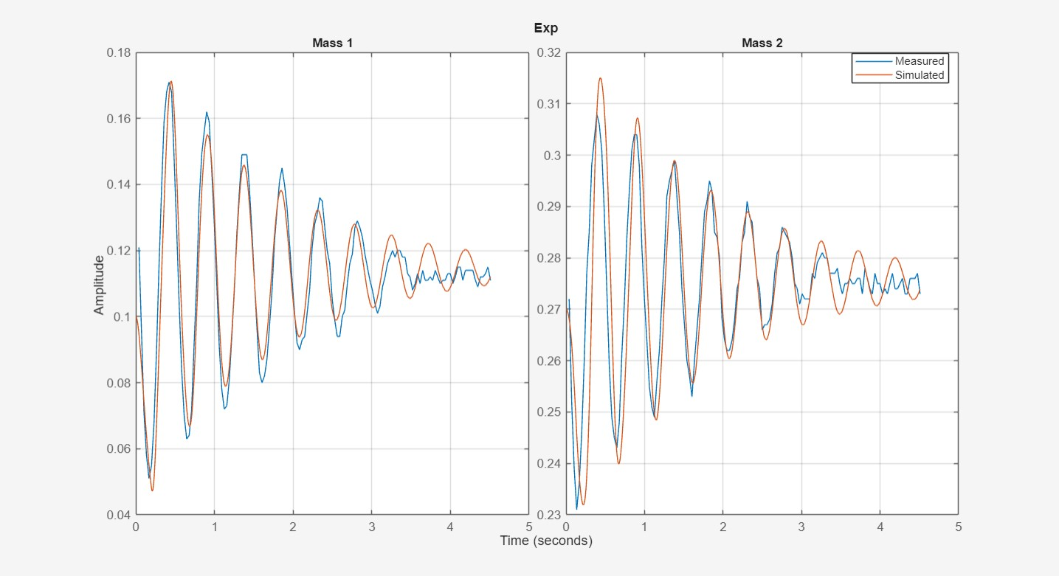

Figure 9: Task 3 Parameter Estimator Plots After Estimation.

The next step is to find the values for the newly configured variables of the Simulink simulation. This is done by returning to the MATLAB window and clicking on each variable and noticing the change. The new parameter values are as follows: b1 = 0.3378, b2 = 0.7862, k1 = 146.5202, k2 = 106.9860, and y = 2.7476. This process can be seen in Figure 10. Most of these variables had a drastic change.

Figure 10: Task 3 MATLAB Variable Assignments After Estimation.

Lastly, returning to the simulation and running it once more with these new variable assignments will result in a new, more accurate, position plot for the system when compared to the original plot from Task 2. This plot can be seen in Figure 11.

Figure 11: Task 3 Updated Spring Mass Damper System Using Simscape Simulation Plot After Estimation.

Based on the resulting plot it can be inferred that the system has all the same characteristics explained at the end of Task 1 which is expected since it is meant to be a representative model simulation of that physical system. The estimation tool has successfully adjusted the simulation to reflect the real-world system much more closely. The amplitude, damping behavior, and frequency of oscillations are all improved, leading to a more accurate model. This is an excellent outcome in terms of modeling the physical spring-mass-damper system using Simulink. Further fine-tuning could focus on capturing any residual noise or imperfections from the physical system.

# Post-Lab Questions

1. What are the final values (to 4 decimal places) for all the estimated parameters from the system (y, k1, k2, b1, b2)?

The parameter values are as follows: b1 = 0.3378, b2 = 0.7862, k1 = 146.5202, k2 = 106.9860, and y = 2.7476.

2. Go back into the block diagram and change mass 1 to equal 0.350 kg and mass 2 to equal 0.500 kg. Do not change the values of the estimated parameters from the previous estimate. Return to the parameter estimator, create a new experiment as you did in task 3 and re-run the estimator. Note: This estimation will take longer than the first estimation. What are the new values for the parameters? Rerun the scope and paste the graph.

The parameter values are as follows: b1 = 0.0160, b2 = 2.1159, k1 = 199.6954, k2 = 72.7627, and y = 2.2249. The resulting plots can be seen in Figure 12, Figure 13, Figure 14, and Figure 15.

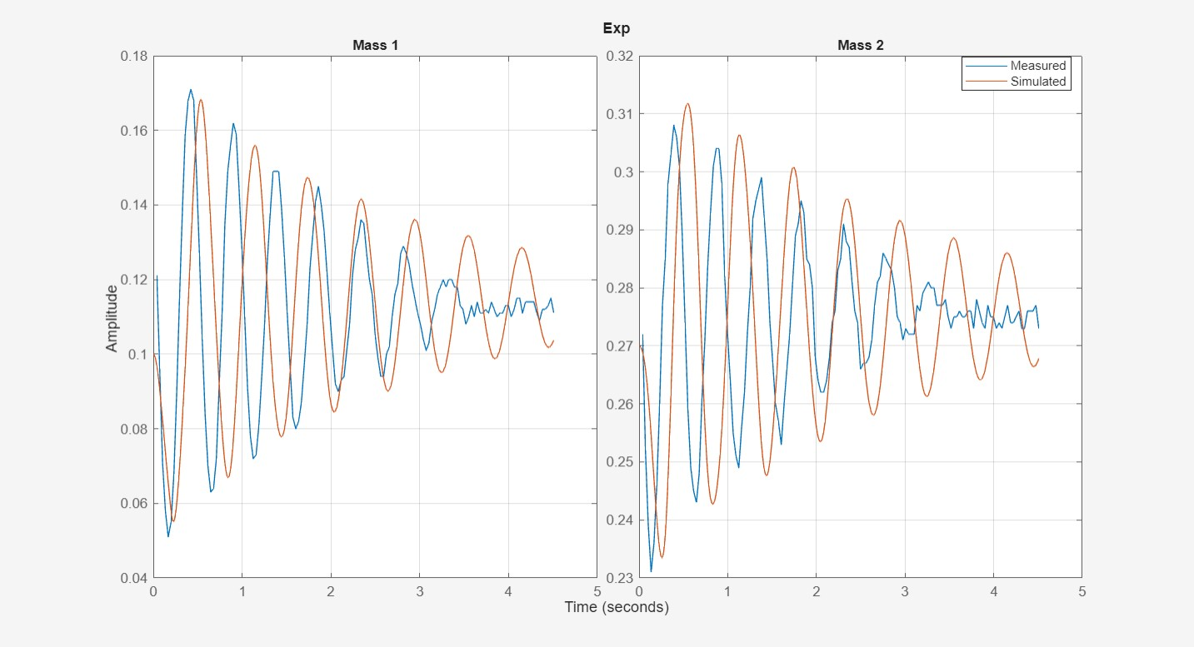

Figure 12: Post Lab Question Parameter Estimator Plots Before Estimation.

Figure 13: Post Lab Question Parameter Estimator Plot During Estimation.

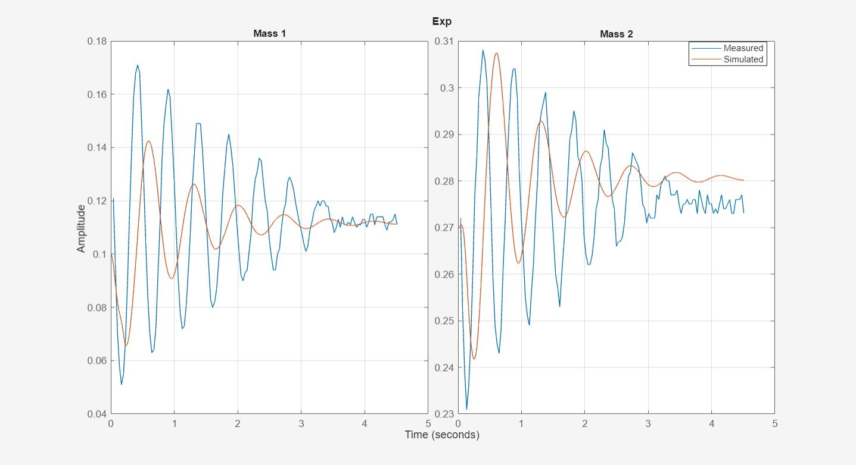

Figure 14: Post Lab Question Parameter Estimator Plots After Estimation.

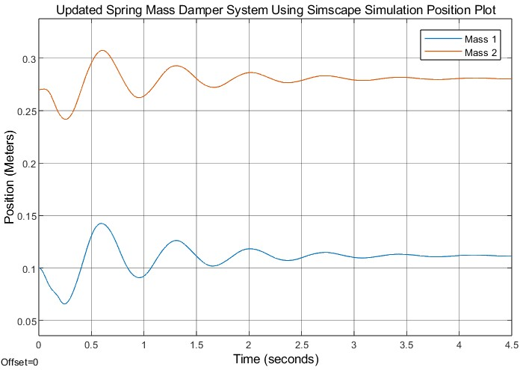

Figure 15: Post Lab Question Updated Spring Mass Damper System Using Simscape Simulation Plot After Estimation.

3. Based on Question 2, what happened to the position scope output? Can we reproduce the same dynamic response (plot) even if the mass is different? Then, why might we choose not to allow the estimator to manipulate the mass along with the other parameters?

The number of oscillations before reaching stability in the position graph significantly decreased compared to previous simulations. The same dynamic response plot cannot be reproduced if the mass is different. Therefore, the estimator should not be allowed to manipulate the mass, as it does with the other parameters, because changing the mass will produce an output that does not result in the expected dynamic response.

4. Why did we change the simulation stop time to 4.5 seconds in step 5 of Task 2?

Since the physical data collected of an oscillating spring was for a duration of 4.5 seconds, which can be concluded by looking at the data or the plot for task 1, the simulation should match that time so it can be compared accurately.

5. The experimental system exhibits some damping despite there not being a traditional translational dampener. What is causing the damping effect?

Because of the natural dampening effect from the Spring caused by friction, heat, and air resistance the experimental system exhibits some damping despite there not being a traditional translational damper.

6. Why is there a difference between the starting position of Task 2 from Task 1? Can we make them similar?

There is a difference because the initial position values for the simulation are set to specified values. For task 2 mass 1 is set to 100mm and mass 2 is set to 270mm. So, yes, the starting positions for task 2 can be made similar to task 1 by configuring the initial position values to match task 1 for each mass in the simulation. This will result in there being a more negligible difference in the starting position of Task 2 from Task 1.

# Conclusion

The purpose of this lab is to expand an individual’s knowledge on how to model a physical two-degree-of-freedom spring-mass-damper system using Simscape libraries in Simulink and MATLAB. Additionally, it aims to demonstrate how to utilize Simulink’s parameter estimation tools, based on experimentally collected data, to better align a simulation model with the behavior of a real-world system. Through the course of this lab, an initial Simulink model was constructed to simulate the spring-mass-damper system. The initial simulation, while showing general underdamped behavior similar to the physical system, exhibited discrepancies in the amplitude and damping rate when compared to the experimental data. These differences highlighted the challenges of translating real-world dynamics into idealized simulations, as the physical system contains factors such as noise, imperfections, and slight variations in parameter values that are not fully accounted for in the initial model. The introduction of Simulink's parameter estimation tool enabled fine-tuning of the model by adjusting key system parameters, such as the spring constants and damping coefficients, using the experimental data as a reference. The updated simulation, after parameter estimation, showed a much closer match to the physical data, with more accurate oscillation amplitudes, damping rates, and steady-state behavior for both masses. This alignment demonstrated the effectiveness of parameter estimation techniques in bridging the gap between theoretical models and real-world systems. In conclusion, the lab successfully achieved its objective of demonstrating how to model and simulate a two-degree-of-freedom spring-mass-damper system. The use of Simscape in Simulink, combined with parameter estimation based on experimental data, proved to be a powerful approach in creating a simulation that accurately reflects the behavior of a physical system. This lab not only enhanced understanding of dynamic system modeling but also emphasized the importance of iterative tuning and estimation techniques in achieving real-world accuracy in simulations.

# References

[1] Author not listed, *Texas A&M University MXET375 - Lab 03 - Spring Mass Damper System*. College Station, TX, USA: Date not listed.

[2] Rex K., *MXET375 - Kyle Rex - Lab Report 2*. College Station, TX, USA: 09/19/2024.